Forgiven-Meditational – Updated
October 26th, 2022

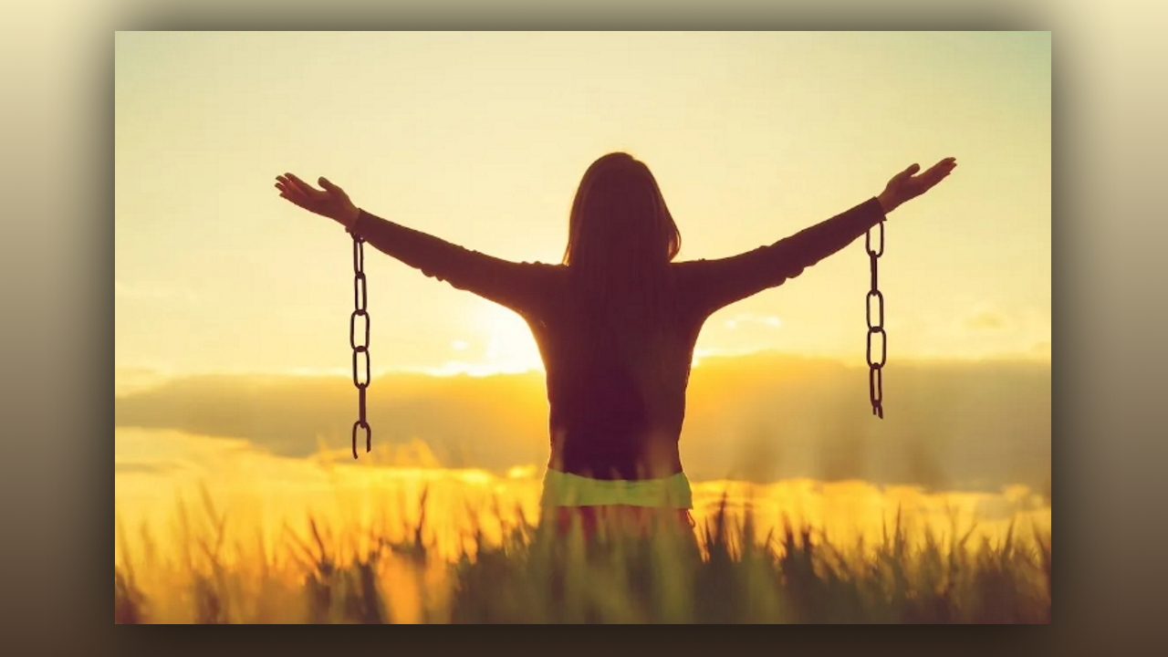
This beautiful park-like atmosphere with willow trees and green maple trees, beautiful green grass. It is a warm afternoon with gentle shadows and gentle sunlight filtering into the trees. Not too far away is a stream, you can hear it gurgling, and this stream has the most amazingly clear water. I have just never seen water this pristine, just absolutely crystal, all the way to the bottom, beautiful white sandy bottom.

There is a bridge across the stream, about ten feet wide. It is a small stream, but it is very deep, and the bridge is an old- fashioned arch shaped bridge with a railing.

Now I would like for you to take a moment and recall to mind your favorite, your very, very favorite, most favorite image of Jesus, the one that really comes alive to you in your heart. And I would like you to see yourself standing with Jesus in the very center of the bridge, over the stream.

He is holding you very tenderly, and your head is on His Heart, and you feel so much comfort being with Him. His arms are around you and He is just holding you gently but securely and you feel such peace.

The water is so clear, you can see moss on the bottom and shells, beautiful even colored shells, but mostly it is a white sandy bottom, pure crystal-clear water.

And now you are going to begin by just worshipping Him, praising Him, so simply, just praising Him.

